Meet the Authors
Launch Weekend Plan


The launch weekend at Oak Hills Church was an exciting and energetic event that created enthusiasm for doing The Story as an entire church family, and generated interest in what they were going to be learning about.
The theme of the launch was “Meet the Authors.” Bible characters who had written books of the Bible were stationed around the building, and they told about their life story, and autographed the maps that people used to locate the Bible characters. (The plan below shows their original idea which was to have the authors sign particular pages of The Story, but that was changed to signing the maps in order to improve the traffic flow.) Every Bible character was stationed in a scene, with a secondary character from their life to play off of, and a stage manager and facilitator who helped manage the crowd, got conversations going, and kept the traffic flowing.
The details below are from a summary sheet Oak Hills developed to describe each of the characters and manage the logistics of the event.

What each role is responsible for:
The Author
- Knows 3-4 different “stories” that he can tell about his life.
- Will facilitate times for Team meetings
Under Story Character
- Prepares a 1-2 minute “story “concerning their involvement with the author/character. Obeying God’s will, thanking God, or beseeching God should be paramount.
The Stage Manager
- Is responsible for everything that goes on “the stage.”
- Makes sure that all costumes are secured
- Controls the conversational flow and the props for the stage.
- Assures that the conversation does not drag
- May address the central actor, the under story actor, the facilitator of the crowd
The Facilitator
- Controls the people who are around the area – asks if they want an autograph, do they have questions, etc…. Communicates to stage manager.
- Has some kind of implement (Scripto) for author to sign a book – Bible or Story – see info concerning where in the following descriptions. Page numbers are from the 2011 version of The Story. Please know where your author has a book in the Bible!

Moses
Under story: Pregnant Sarah (Moses, the author, wrote about Abraham and Sarah) – very happy as God fulfills His promise to her and Abraham. Portrayed by an elderly lady with a pillow under her dress!
Props: pillows, stools, low table, goblets, tablet
Book signing: page 44, where Moses is named by Pharoah’s daughter
Bible signing: Exodus 2:10
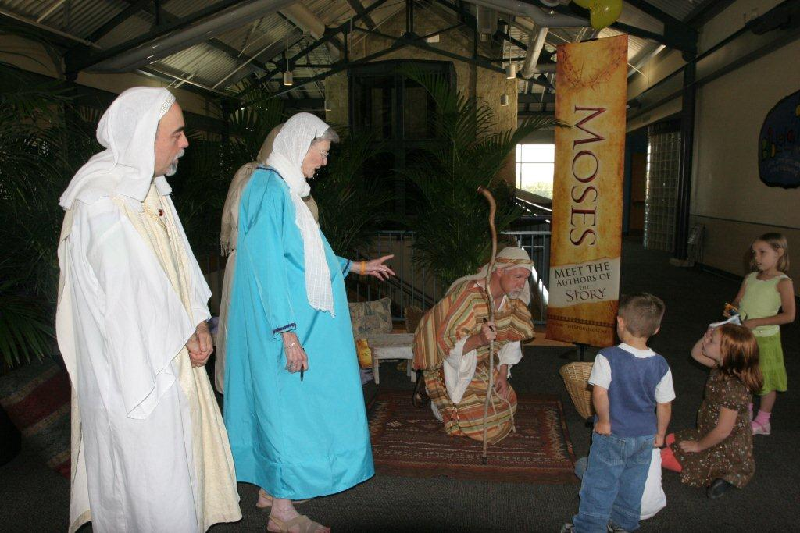

David (on the run)
Under story: Ruth, his great grandmother, who through her obedience to God, changed the world with her lineage.
Props: Pillows, stools, low table, goblets
Book signing: page 146, David’s lineage
Bible signing: Psalms 53, 54, 55, 56
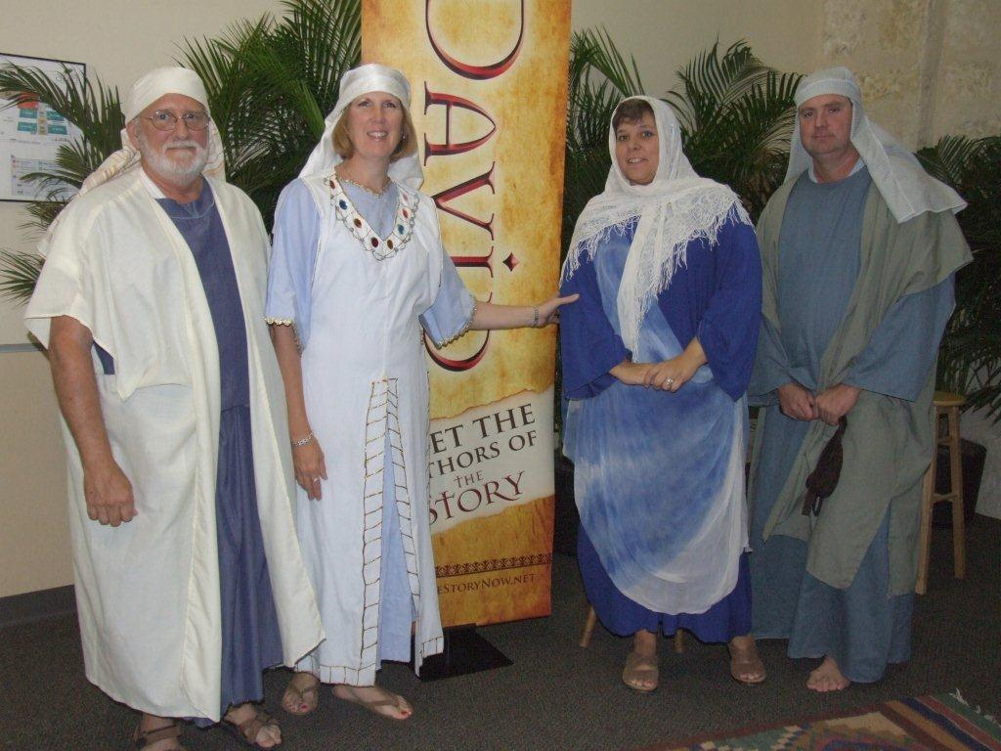

King Solomon
Under story: Woman with the baby who was saved by Solomon because he chose to be given wisdom from God.
Props: Throne, pillows, goblets, etc.
Book signing: page 179, the Proverbs of Solomon
Bible signing: Song of Solomon

Daniel
Under story: King Nebuchadnezzar and his wife, who through quite an ordeal, found God.
Props: Throne, pillows, goblets, etc.
Book signing: page 249
Bible signing: Book of Daniel
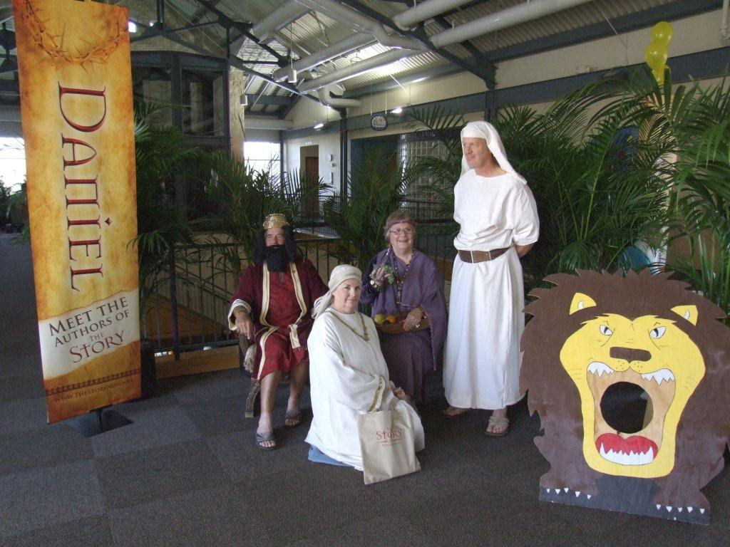
Jonah
Under story: 3 young sailors who, very reluctantly, had to throw Jonah off of the ship.
Props: Whale
Book signing: Inside front flap, on the map at Nineveh
Bible signing: Book of Jonah

Matthew, Mark, Luke and John
Under story: Mary Magdalene, one of few women mentioned by all Gospel writers, as she recounts the stone moved away!
Props: Pillows, goblets, stools, big rock, etc…..
Book signing: Matthew – page 333, Mark – page 354, Luke – page 369, John - page 309
Bible signing: First four books of New Testament

Paul
Under story: Conversion of Lydia who opens her heart to God and her home to Paul.
Props: Pillows. Stools, goblets, etc….
Book signing: page 416, Paul’s letter to the Thessalonians
Bible signing: Romans

Peter
Under story: Cornelius begging God for someone to preach and recounts Peter coming.
Props: Pillows, stools, etc…
Book signing: page 391, Peter’s sermon at Pentecost
Bible signing: 1 & 2 Peter

General Overview
- All teams will meet as units prior to the launch weekend for a dress rehearsal
- All areas are defined by props and plants, and have accompanying music or sound effects
- All portrayers, managers, facilitators and under story actors are dressed in appropriate attire. A few are royals and will need to be dressed accordingly.
- Distribute maps of the church showing author locations
- Place Meet the Author 2’ X 3’ banners at each location
- People will rotate from one author to another. Consider rotation time to be approximately 5 minutes.

