The Story Staging Ideas
Lutheran Church of Hope, West Des Moines, Iowa
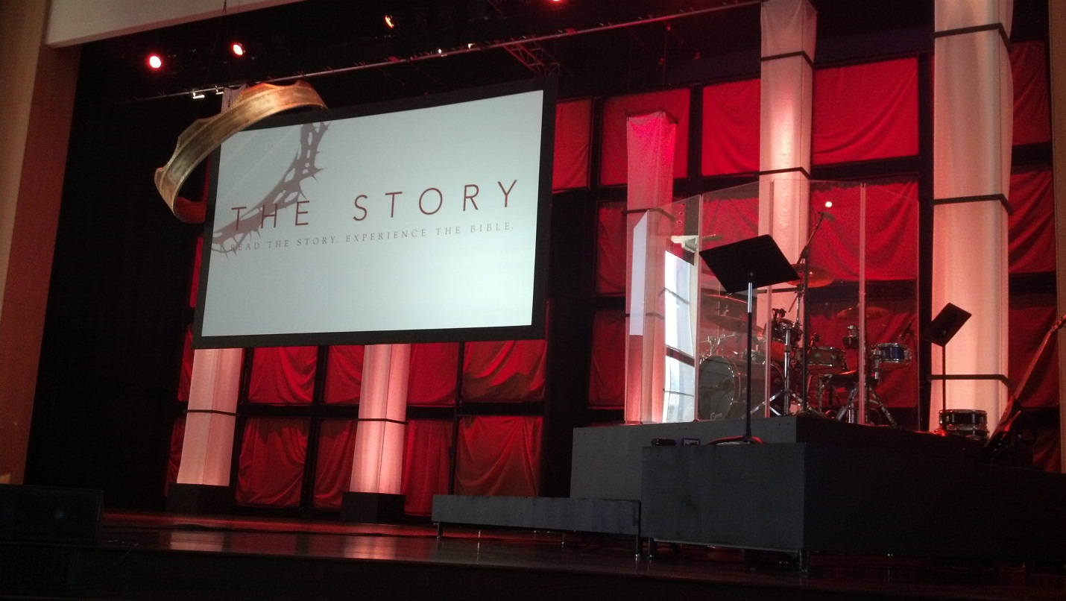

Riverlakes Church, Bakersfield, California
Adaptation of stage banners by Southeast Christian Church, available in Online Resource Library, on the Bulletin Board

Weeks 0-5
Note: they are doing the introductory Deal or No Deal message, with their elders dressed in tuxes and dark glasses!
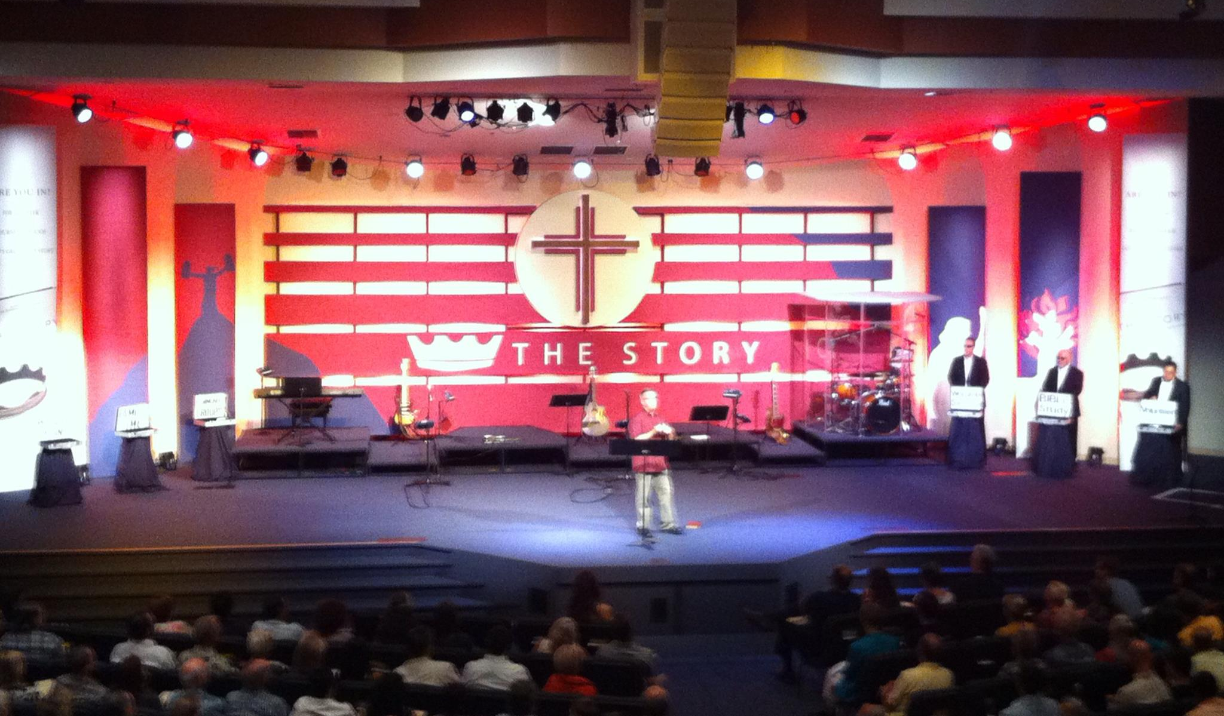
Weeks 11-14

