The Story Timeline Ideas

**The Covenant Church, Cheboygan, Michigan**

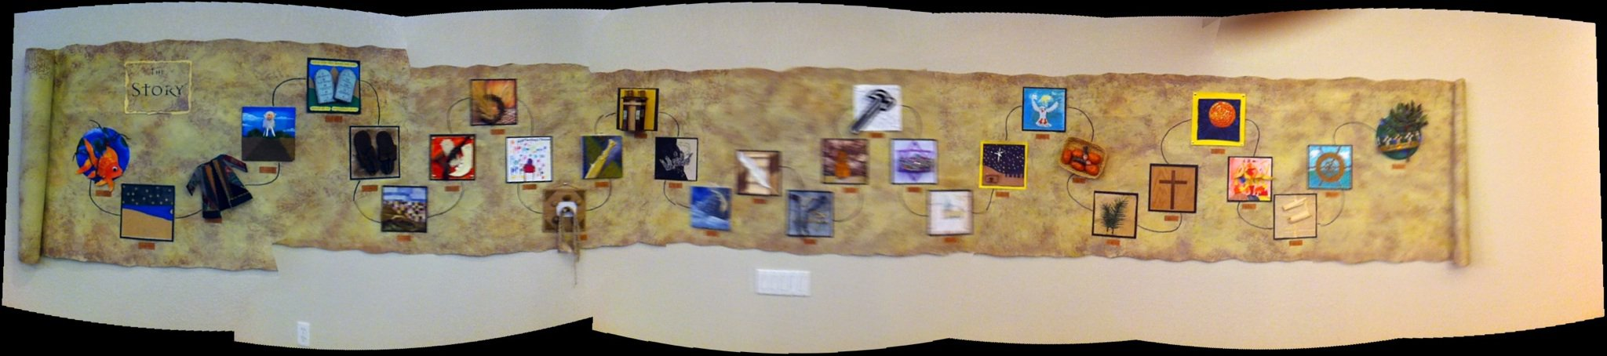

*One of the best things we did as part of The Story was a 31 week art series with different people in the church creating a piece of artwork that went on the pulpit and was then added to a giant scroll on the wall.  Here is a link to see the individual artwork:* <http://www.covchurchcheboygan.com/?p=939>  
  
**Glen Ellyn Evangelical Covenant Church, Glen Ellyn, Illinois**

*Original artwork by local artist*

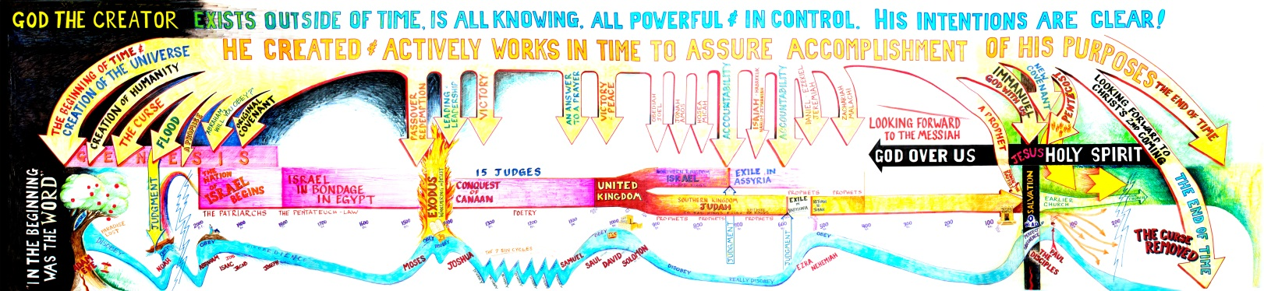

**Southeast Christian Church, Louisville, Kentucky, Children’s Wing**

*Printable posters, found on Story for Children and Story for Kids CD-Roms*

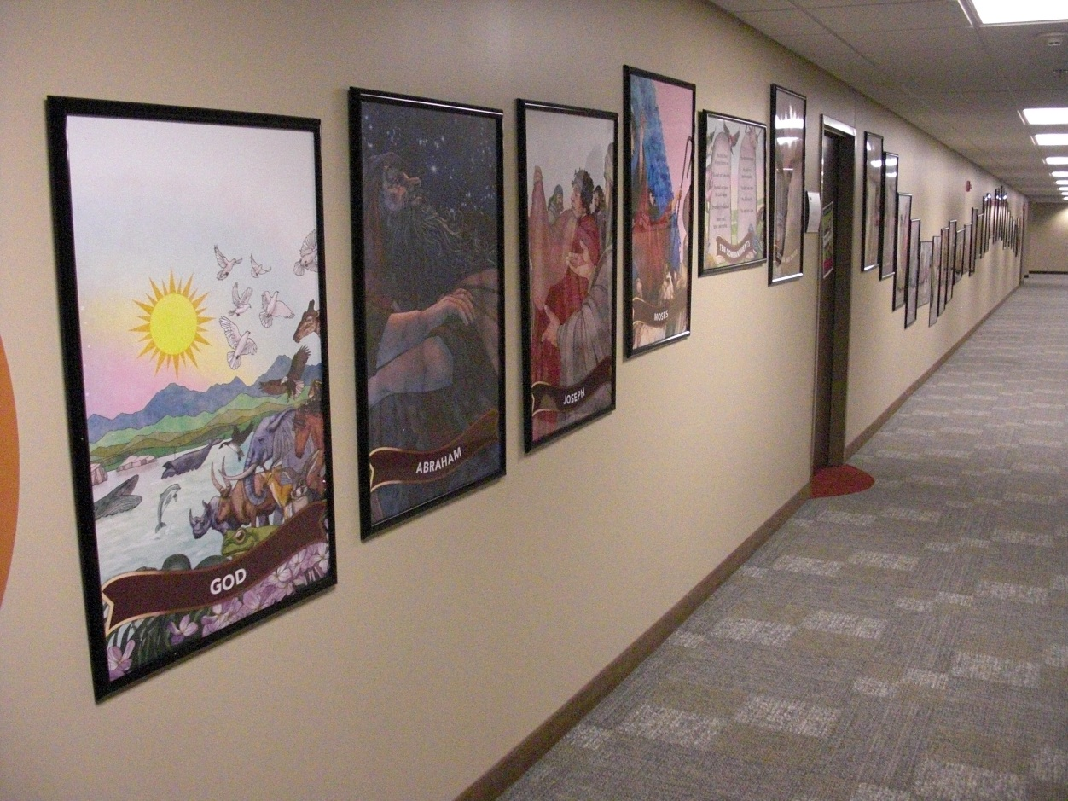

**Le Roy Christian Church, Le Roy, Illinois**

*Original art by church member*

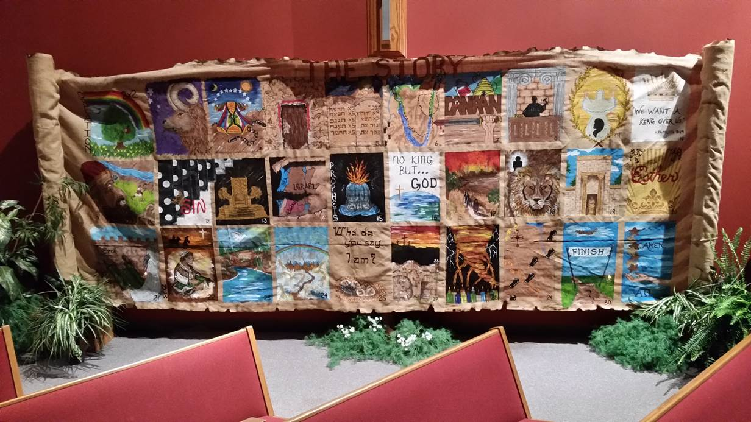

*Lisa Lunn created an icon for each chapter, and painted one on the scroll each week. Chapters 26 and 27 are together (cross/empty tomb).* ***Materials:*** *burlap (with burned edges and spray-starched top border), acrylic paints, cardboard tubes from carpet rolls on stands of PVC pipe, joined at the top by a wood cross-bar to which the burlap is stapled.*